Configuring Sticky Selectron

Data Sources

Sticky Selectron supports selecting records from a single object, standard or custom. The selection of the object is defined during configuration.

Sample Flow

Sticky Selectron comes with a Sample flow called Sticky Selectron Example Account Flow. This flow is deactivated and intended to demonstrate how to use Sticky Selectron. The example flow is optional when using MetaDEPLOY to install Sticky Selectron, it is a good example and can be deleted later from Flows. See the [Example Flows](https://sfdo-community-sprints.github.io/SSSFDG/docs/example-flows/) page for more information. This sample flow is referenced as example information in the configuration settings below.

Known Field Display Limitations

Join us in making Sticky Selectron even better! These are the currently identified limitations for field display (and are part of our planned feature list).

* Date/Time display are displayed as system values
* Relationship fields display the ID of the related record. You can, however, display a formula field that references a related object.
* Field Labels are displayed as column headers.

Configure Resources

The flow will need to reference a set of variables (Collection Variables, Record collection Variables, and Variables) that you will need to build for the Sticky Selectron to reference them in configuration. We recommend that you create these resources before configuring Sticky Selectron.

Below is a list of the Resources you will need to create and how they are used/populated. The sample collection names are from the sample flow (Sticky Selectron Example Account Flow) provided in the package. You will be creating the following New Resources in your flow:

* 2: **Collection** Variables of Data Type TEXT, which allow multiple values and are available for input.
* 2: **Collection** Variables of Data Type RECORD, which allow multiple values and are available for input and output.
* 2: Variables of Data Type NUMBER; these are not collections, do not allow multiple values and have zero decimal places and a default value of zero.

| **Description** | **Type** | **Assignment/Use** | **Sample Name from flow** |
| --- | --- | --- | --- |
| **Collection Variable:** Used to configure which columns should display on the left *selectable* side of the Sticky Selectron Table | Resource Type: Variable,  Data Type: Text,  Allow Multiple values (collection): True,  Available for input: True | Populated with an assignment element in the flow. See **Assign Column Display Collection Variables** | inputTableFieldNames |
| **Collection Variable:** Used to configure which columns should display on the right *selectable* side of the Sticky Selectron Table | Resource Type: Variable,  Data Type: Text,  Allow Multiple values (collection): True,  Available for input: True | Populated with an assignment element in the flow. See **Assign Column Display Collection Variables** | selectedTableFieldNames |
| **Record Collection Variable:** Record collection is used to store the records that should be displayed on the left *selectable* side of the Sticky Selectron Table | Resource Type: Variable, Data Type: Record,  Allow Multiple values (collection): True Object: The object you are selecting from, , Available for input: True,  *Available for output: True IS THIS THE CASE?* | Populated from within the flow with a *Get Records* Element or passed to the flow from another process | inputAccountList |
| **Record Collection Variable:** Record collection is used to store the records that should be displayed on the right *selectable* side of the Sticky Selectron Table | Record Type: Variable,  Data Type: Record,  Object: The object you select from,  Allow Multiple values (collection): True,  Available for input: True,  *Available for output: True IS THIS THE CASE?* | Populated by Sticky Selectron when users select records from within the screen flow.  **NOTE:** If you want to pre-populate this collection, make sure the same records are also populated in the selectable Record Collection Variable *TEST THIS* | selectedAccountList |
| **Variable:** Count of records in the SELECTABLE Record Collection Variable | Resource Type: Variable, Data Type: Number,  Allow Multiple values (collection): False,  Decimal Places: 0,  Default Value: 0 | Populated by Sticky Selectron. You can reference this variable elsewhere in your flow | listCount |
| **Variable:** Count of records in the SELECTED Record Collection Variable | Resource Type: Variable,  Data Type: Number,  Allow Multiple values (collection): False,  Decimal Places: 0,  Default Value: 0 | Populated by Sticky Selectron. You can reference this variable elsewhere in your flow | selectedListCount |

**Assign Column Display Collection Variables**

Using an Assignment Element - Assign the columns you wish to display to the two collection variables you created to store the information. In the Sticky Selectron Example Account Flow, this is demonstrated with two assignment elements. Still, it is possible to assign both collection variables to the same assignment element. Please note that you use the ‘**Add**’ Operator, and you will type in the **API name** of the fields you want to display for the Object Sticky Selectron.

|  |  |  |
| --- | --- | --- |
|  |  |  |
|  |  |  |
|  |  |  |
|  |  |  |
|  |  |  |
|  |  |  |
|  |  |  |
|  |  |  |
|  |  |  |

|  |  |  |
| --- | --- | --- |
|  |  |  |
|  |  |  |
|  |  |  |

Advanced drop-down

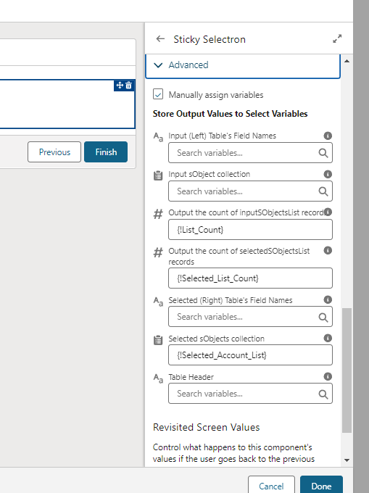

Adding and Configuring Sticky Selectron

Sticky Selectron is available from a Screen Element in Edit mode. Select Sticky Selectron from the Components tab and drag it onto the screen. Once Sticky Selectron is on the screen element, click on it to configure it. Please follow the next section (Configuration Options) for information on configuring each setting.

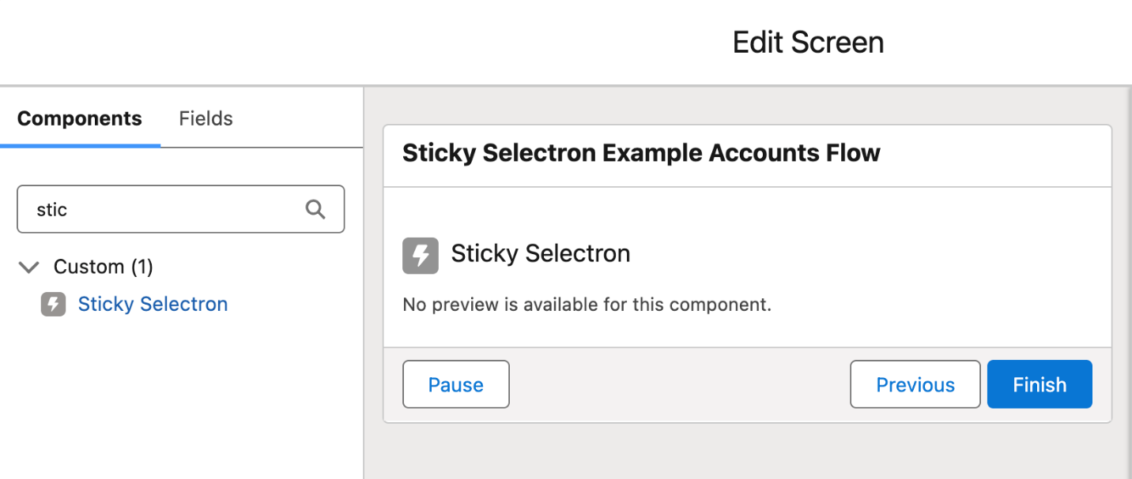

|  |  |  |
| --- | --- | --- |
|  |  |  |
|  |  |  |
|  |  |  |
|  |  |  |
|  |  |  |
|  |  |  |
|  |  |  |
|  |  |  |
|  |  |  |

|  |  |  |
| --- | --- | --- |
|  |  |  |
|  |  |  |
|  |  |  |

Next review the [Example Flows](https://sfdo-community-sprints.github.io/SSSFDG/docs/example-flows/) page to see how to build the flow.